# **THE HISTORY OF US BANKING**

## **A BRIEF OVERVIEW:**

## 1. Early Beginnings:

* **1780s:** Banking in the United States began around the time of the country’s founding. The first chartered bank was the **Bank of North America**, established in **1782** in Philadelphia. [It provided credit to the newly formed government during the American Revolution](https://www.atlantafed.org/economy-matters/banking-and-finance/viewpoint/2016/12/06/history-of-bank-regulation).

## 2. Rise of Commercial Banking:

* In the first half of the **19th century**, smaller commercial banks within New England were easily chartered due to open franchise laws. These banks played a crucial role in providing capital for entrepreneurs to grow their enterprises.
* [Despite some discriminatory practices, these banks remained sound, encouraging financial evolution in the United States](https://en.wikipedia.org/wiki/History_of_banking_in_the_United_States)

## 3. National Banks:

* **1781:** The **Bank of North America** (established by Congress) became the first national bank, superseding the state-chartered **Bank of Pennsylvania**.
* **1791:** The **Bank of the United States**, proposed by Alexander Hamilton, served as a repository for federal funds and the government’s fiscal agent. Although profitable, its charter was not renewed in **1811.**

## 4. Modern Banking:

* Today, the U.S. banking system is highly influential and complex. [Anchored by New York City and Wall Street, it encompasses various financial services, including private banking, asset management, and deposit security](https://en.wikipedia.org/wiki/Banking_in_the_United_States).

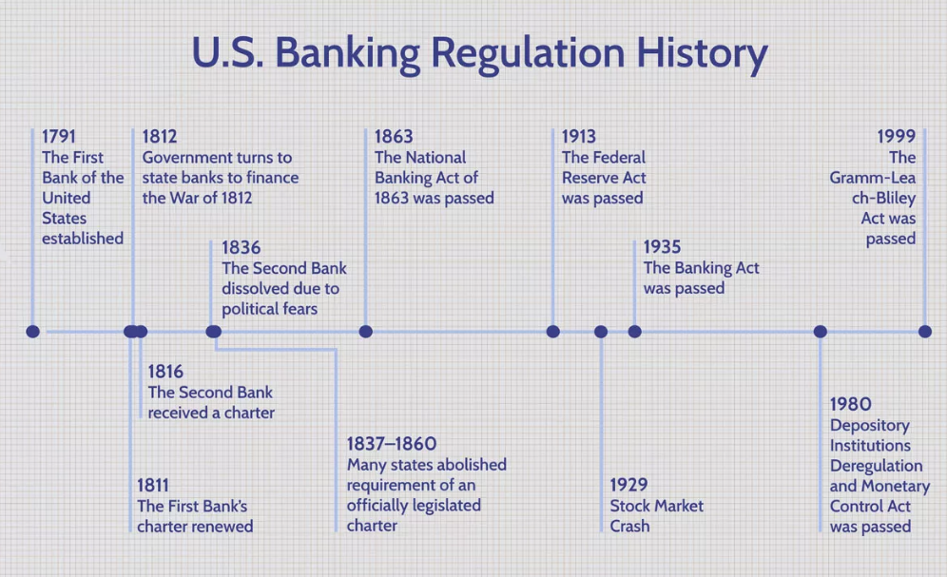

### **KEY TAKEAWAYS**

* As the U.S. evolved into the world's largest economy, its regulatory framework has evolved as well.
* Early regulations aimed to foster economic financial stability through centralized control of the banking system. Opponents, however, maintained that such regulatory authority gave the federal government too much power in comparison to the states.
* In the years following the Civil War, an assortment of financial crises and bank panics led to new regulations. The Great Depression of the 1930s also gave rise to significant reforms.
* The 1980s saw a move toward deregulation, soon followed by re-regulation in the wake of the subprime mortgage crisis and the Great Recession of the early 2000s.

**DETAILED EXPLANATION:**

## **The First and Second Banks of the United States**

* [The First Bank of the United States](https://www.investopedia.com/first-bank-united-states-5217537) was established in 1791. Although it helped bring a degree of economic stability to the young nation, many feared that it gave undue powers to the federal government and considered it unconstitutional. As a result, its charter was not renewed in 1811.
* The U.S. government turned to state banks to finance the War of 1812, but with the significant over-expansion of credit that followed, it became apparent that financial order needed to be restored.
* In response, the Second Bank of the United States was chartered in 1816. It, too, would succumb to political fears over the amount of control it gave the federal government and it was dissolved in 1836.

## **The End of Charters, the Rise of Free Banking**

* Obtaining an official legislative charter was highly political at both the federal and state levels, depending more on political connections than proven competence in financial matters. The bribing of legislators was fairly common.
* By the time the Second Bank dissolved, a new era of free banking was emerging, with a number of states passing laws in 1837 that abolished the requirement that banks obtain an officially legislated [charter](https://www.investopedia.com/terms/c/charteredbank.asp) to operate. By 1860, a majority of states had passed such laws.
* During this time of free banking, anyone could operate a bank on the condition that all the notes it issued were backed by proper security. While that helped reinforce the credibility of [banknotes](https://www.investopedia.com/terms/b/banknote.asp), it did not guarantee immediate redemption [in specie](https://www.investopedia.com/terms/i/in_specie.asp) (gold or silver), which would serve to be a crucial point.
* The era of free banking suffered from financial instability, including several banking crises. It also made for a chaotic [currency](https://www.investopedia.com/terms/c/currency.asp) market, characterized by thousands of different banknotes circulating at varying discount rates. This instability and disorder led to a renewed call for more regulation and central oversight in the 1860s.

## **National Banks: 1863-1913**

The outbreak of the Civil War and the need to finance it led again to a renewed interest in a national bank. But this time, with the lessons of the Second Bank, the designers took a different approach, modeled on the free banking system. In 1863, they established what is now known as the “national banking system.”

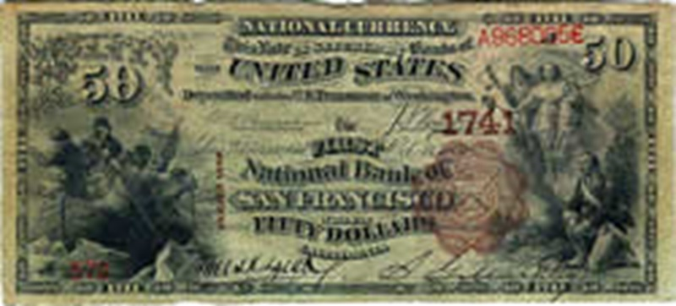

**National Bank Note, First National Bank of San Francisco, 1890, $50**American Currency Exhibit, Federal Reserve Bank of San Francisco

The new system allowed banks to choose between a national charter and a state charter. With a national charter, banks had to issue government-printed bills for their own notes, and the notes had to be backed by federal bonds, which helped fund the war effort. In 1865, state bank notes were taxed out of existence. Thus, in spite of all previous attempts, this was the first time a uniform national currency was established in the United States.

## **Conclusion**

While it’s clear from this chronology that central banking in the United States has evolved over time, a shared motivation throughout this history is also apparent—to better serve commerce and government. That was the inspiration behind Alexander Hamilton’s campaign to establish the First Bank of the United States, behind the efforts of the Second Bank and the banking legislation that followed, and the core purpose behind the Federal Reserve Act. And those objectives will certainly continue to motivate Congress and the Federal Reserve as they contemplate future changes in the operations of the nation’s central bank. While Hamilton would not recognize many functions of modern central banking, he would certainly recognize its goals.